**Company Name:**

**AthleticGear**

**Industry:** Sports Equipment and Apparel

**Business Model:** B2C (Business-to-Consumer) and B2B (Business-to-Business)

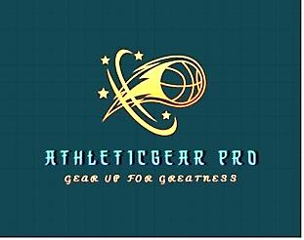**Author’s Name**: Amaresh Chandra Mondal

**Roll No:** 01-050-20

**Batch**: 50

**Date:** 18-12-2024

Contents

Founder/CEO: Md. Mazba Uddin. 1

Mission Statement 3

Vision 3

Executive Summery: 3

Products and services of this company offers 4

1. Sports Apparel 4

2. Footwear 4

3. Sports Equipment 4

4. Accessories 4

5. Customization Services 4

6. Expert Advice and Guidance 4

7. Online Shopping Experience 5

Product Line 5

Sports Kits 5

Apparel: 5

Target Market 6

Primary Market: 6

Secondary Market: 6

Competitive Advantage 6

Marketing Strategy 6

Sales Channels 7

Operations Plan 7

Financial Plan 7

Management Team 7

Business Plan 9

Sales and Cost Statistics 10

# Mission Statement

To provide high-quality, innovative sports kits and apparel that enhance athletic performance and foster team spirit. We aim to serve athletes and teams with products that combine superior design, functionality, and comfort.

# Vision

To become a leading provider of sports kits globally, known for our commitment to quality, customization, and customer satisfaction.

# Executive Summery:

AthleticGear is a sports equipment company dedicated to providing athletes with high-quality gear to enhance their performance and enjoyment of various sports and activities. With a focus on professionalism and expertise, AthleticGear offers a wide range of athletic equipment, including apparel, footwear, and accessories, designed to meet the needs of athletes of all levels. The company's commitment to quality and innovation ensures that customers can gear up with confidence, knowing they are equipped for greatness in their chosen pursuits.

Products and services of this company offers**:**

AthleticGear offers a comprehensive range of products and services tailored to the needs of athletes across various sports and activities. Here's an overview:

1. 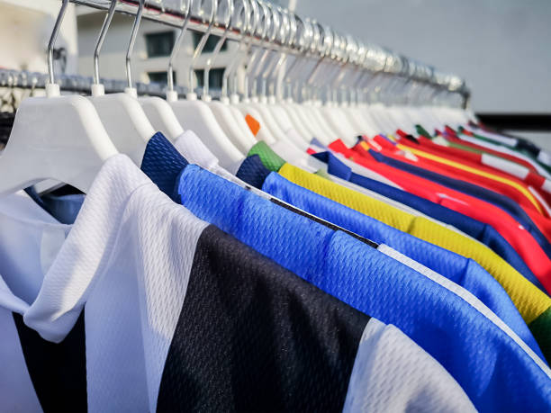Sports Apparel: High-performance clothing designed for comfort, flexibility, and durability during [athletic activities](https://wearebraindead.com/collections/oakley-factory-team?gad_source=1&gclid=CjwKCAjwmYCzBhA6EiwAxFwfgM9nLt2pYGbPc1f9w0EItBOap-8e7SscK_MImeO7N4KPyarjq2mXPxoCoEYQAvD_BwE). This includes shirts, shorts, leggings, jackets, and sport-specific apparel for activities such as running, basketball, soccer, and more.
2. 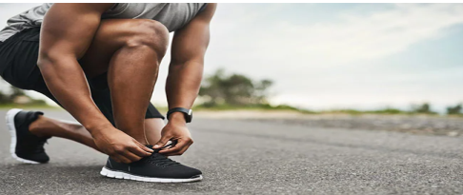Footwear: A selection of athletic shoes engineered for optimal support, traction, and performance across different sports. This includes running shoes, basketball sneakers, soccer cleats, training shoes, and more.
3. 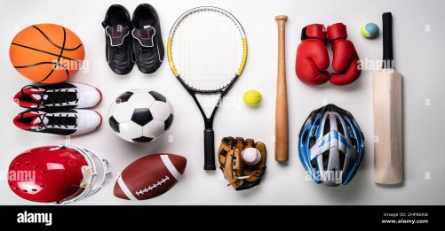[Sports Equipment](https://sportsworld.com.bd/): A diverse array of sports equipment to enhance training and performance. This may include items such as basketballs, soccer balls, footballs, tennis rackets, golf clubs, and other sports-specific gear.
4. 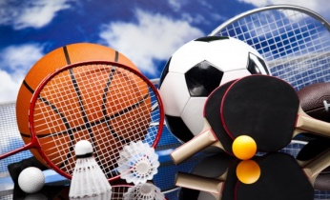Accessories: A variety of [accessories](https://www.kablewala.com.bd/sports-and-outdoor/sports-and-accessories.html) to complement athletic pursuits and enhance the overall experience. This may include sports bags, water bottles, sweatbands, compression sleeves, protective gear, and more.
5. [Customization Services](https://klabu.org/teamwear?gad_source=1&gclid=CjwKCAjwmYCzBhA6EiwAxFwfgMLr_fkty26a41BF3S1mZAPCz1Dva0cGx1s5WcrzksRJktCcDGVAahoCOqIQAvD_BwE): Personalization options such as custom team uniforms, personalized jerseys, and branded apparel for sports teams, schools, or organizations.
6. Expert Advice and Guidance: Knowledgeable staff and resources to provide expert advice on product selection, sizing, and usage, ensuring customers find the right gear for their specific needs and preferences.
7. Online Shopping Experience: An intuitive and user-friendly online platform for convenient browsing, purchasing, and delivery of athletic gear, accessible to customers worldwide.

# Product Line

## **Sports Kits**

* **Soccer Kits:** Jerseys, shorts, socks, and training gear.
* **Basketball Kits:** Jerseys, shorts, and warm-up apparel.
* **Baseball Kits:** Uniforms, caps, and accessories.
* **Running Gear:** Lightweight, breathable shirts, shorts, and accessories.
* **Custom Team Kits:** Fully customizable kits for various sports.

## **Apparel:**

* **Training Wear:** Hoodies, sweatpants, and training tops.
* **Compression Wear:** Compression shirts, shorts, and leggings.
* **Outerwear:** Jackets and windbreakers for various weather conditions.
* **Accessories:** Caps, socks, and gloves.

# Target Market

## **Primary Market:**

* **Amateur and Professional Athletes:** Individuals looking for high-quality sports kits and training gear.
* **Sports Teams and Clubs:** Schools, colleges, local leagues, and professional teams seeking custom team kits.

## **Secondary Market:**

* **Fitness Enthusiasts:** Individuals engaged in regular physical activity who need durable and comfortable sportswear.
* **Corporate Clients:** Businesses looking for custom sports kits for team-building events and corporate sports teams.

# Competitive Advantage

1. **Customization Options:** Offering extensive customization for team kits, including logos, colors, and player names.
2. **Quality Assurance:** Using high-quality materials and advanced manufacturing techniques to ensure durability and comfort.
3. **Innovative Designs:** Partnering with experienced designers to create stylish and functional sportswear.
4. **Customer Service:** Providing exceptional customer support to ensure satisfaction and loyalty.
5. **Sustainability Practices:** Implementing eco-friendly materials and processes to reduce environmental impact.

# Marketing Strategy

1. **Digital Marketing:** Utilizing social media, SEO, and online advertising to reach a wide audience.
2. **Influencer Partnerships:** Collaborating with athletes and fitness influencers to promote our products.
3. **Sponsorships:** Sponsoring local and regional sports events to increase brand visibility.
4. **Content Marketing:** Creating engaging content such as blogs, videos, and tutorials related to sports and fitness.
5. **Email Campaigns:** Running targeted email campaigns to keep customers informed about new products and promotions.

# Sales Channels

1. **E-Commerce Website:** A user-friendly online store for direct-to-consumer sales.
2. **Sports Retailers:** Partnering with sports equipment and apparel stores to reach more customers.
3. **Direct Sales:** Selling directly to teams, schools, and organizations.
4. **Online Marketplaces:** Utilizing platforms like Amazon and eBay to expand reach.

# Operations Plan

1. **Design Team:** A dedicated team of designers to create innovative sports kits.
2. **Supplier Partnerships:** Establishing relationships with reliable suppliers for high-quality materials.
3. **Manufacturing:** Deciding between in-house manufacturing or outsourcing to reputable manufacturers.
4. **Quality Control:** Implementing strict quality control measures to ensure product excellence.
5. **Logistics:** Efficiently managing inventory, shipping, and delivery to ensure timely fulfillment.

# Financial Plan

1. **Startup Costs:** Estimating initial expenses including design, production, marketing, and legal fees.
2. **Revenue Streams:** Projecting income from direct sales, custom orders, and bulk purchases by teams and organizations.
3. **Pricing Strategy:** Setting competitive prices to attract customers while ensuring profitability.
4. **Funding:** Exploring options such as personal savings, business loans, or investors for initial funding.
5. **Financial Projections:** Creating detailed financial forecasts for the first three years of operation.

# Management Team

**Founder/CEO: Md. MazbaUddin**. Oversees overall strategy, business development, and operations.

**Design Lead: Dipayan Das.** Heads the design team, ensuring innovative and high-quality product designs.

**Marketing Director: Rakib Hossain.** Develops and executes marketing strategies to build brand awareness and drive sales.

**Sales Manager: Robiul Khan.** Manages sales channels, customer relationships, and business partnerships.

**Operations Manager: Sifatuzzaman Sesir.** Ensures efficient production, quality control, and logistics.

**Customer Service Manager: Hrido Mozahid.** Leads the customer support team to provide excellent service and handle inquiries.

# Business Plan

Market Research

Potential market

Create Business Plan

No Potentiality

Legal and Financial Setup

Design and Production

Branding and Marketing

Sales and Distribution

Customer Service and Feedback

Positive Feedbck

Negative output

Continuous Improvement

# Sales and Cost Statistics



**Conclusion:** Athletic Gear aims to become a trusted name in the sports equipment and apparel industry by delivering high-quality, customizable products and exceptional customer service. With a clear vision, strong values, and a comprehensive business plan, Athletic Gear is poised for success in a competitive market.